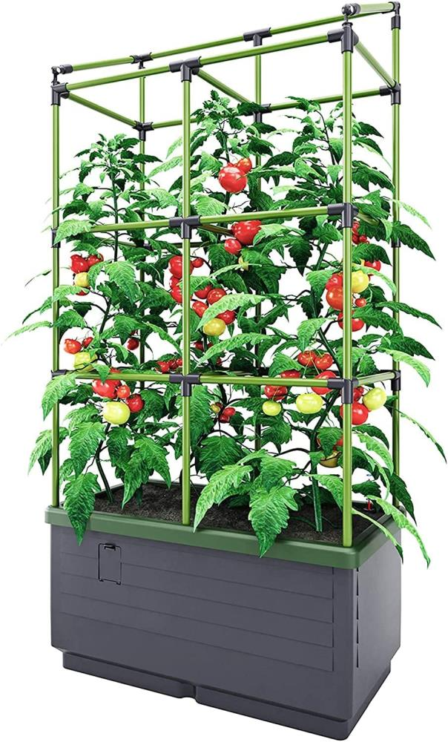
City Jungle Tower
17L water tank
Built in trellis
Durable and weather resistant
Easy to set up
L62xW33xH128cm

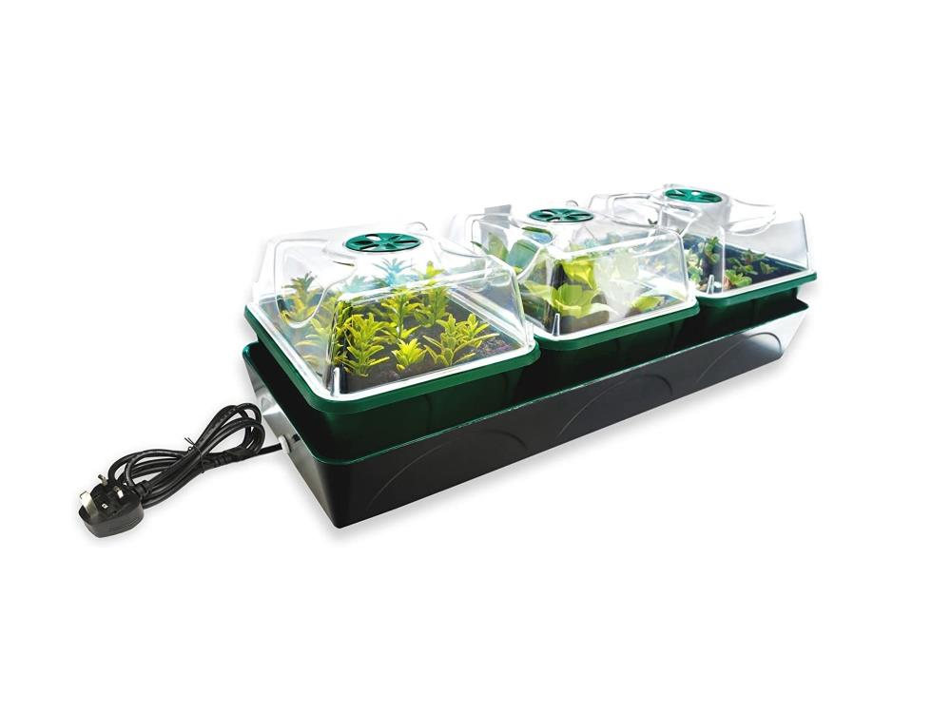
Hollandia windowsill propagator
Perfect for windowsills or small space
Heated growing box (12.5w)
1.4L water tank with capillary matting
Ventilation
Removable planting chambers
L54xW21xH17cm

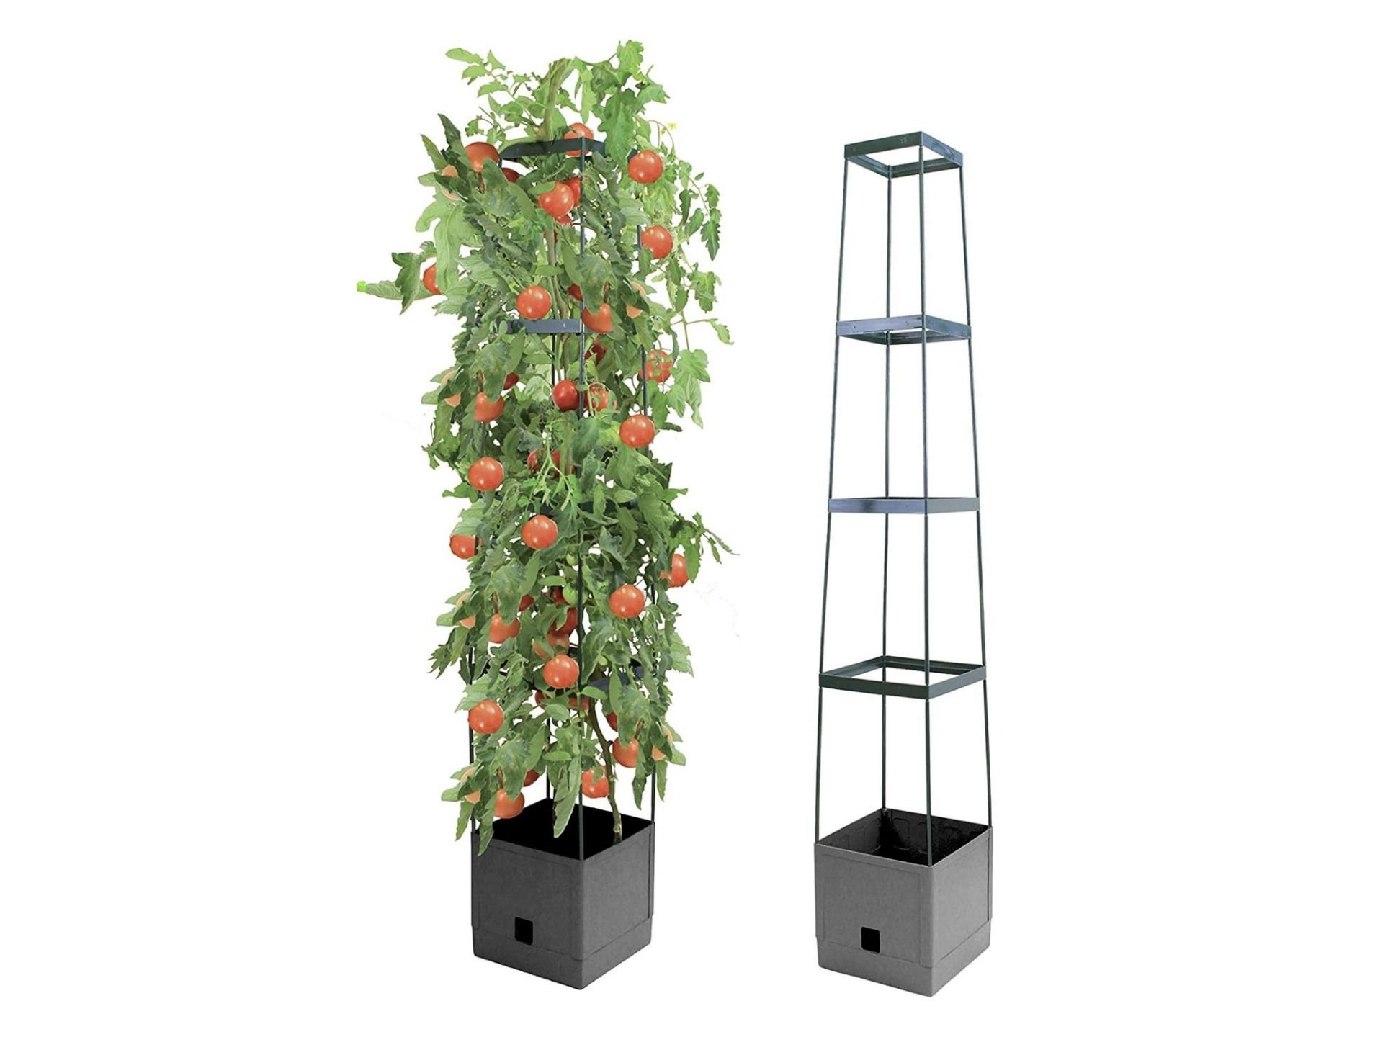

Maxitom plant tower
Self-watering with 2L reservoir
16L soil capacity
H150cm
Comes in grey or terracotta

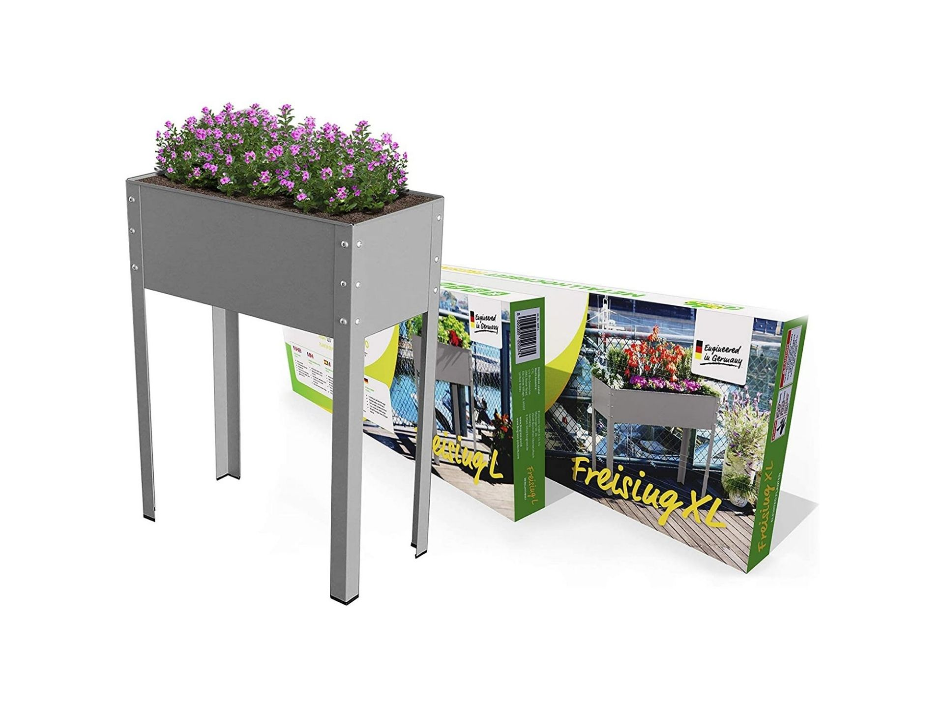
Metal raised bed
For indoor or outdoor use
Suitable for vegetables, flowers and herbs
Planting dimension 80x30cm
Comes in two heights
60cm & 100cm

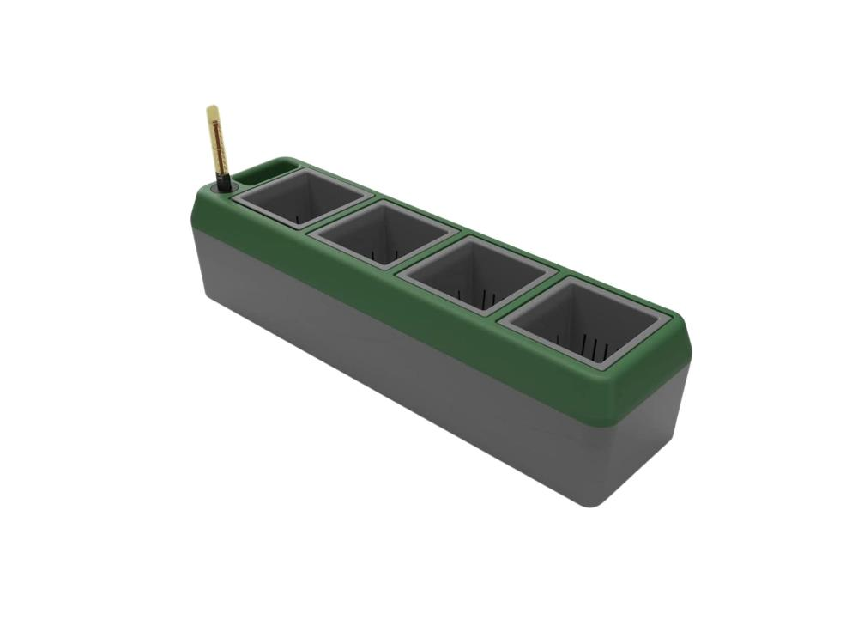
Provence herb planter
Has a self-watering system with 2L water storage
4 removable planting baskets
L24xW12xH11cm

