Planters
2026


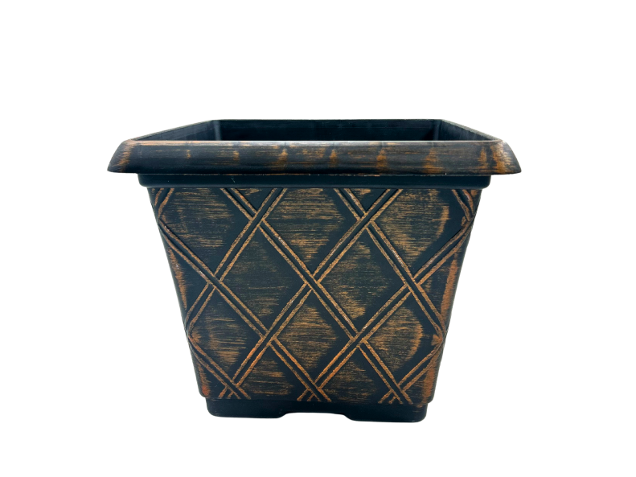
Malpas planter
Square decorative plastic planter
40cm Black/Gold

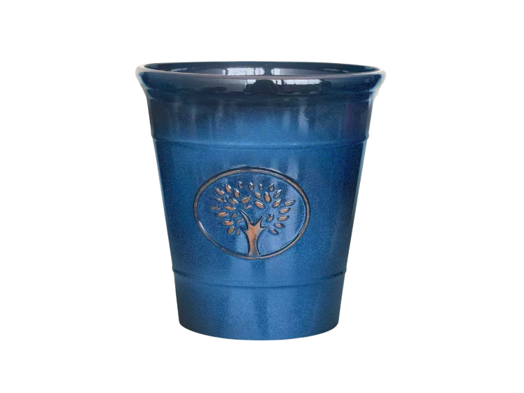
Sycamore planter
Made from recycled polypropylene
Blue/black/grey/off white/sea green
30cm - 40cm - 50cm

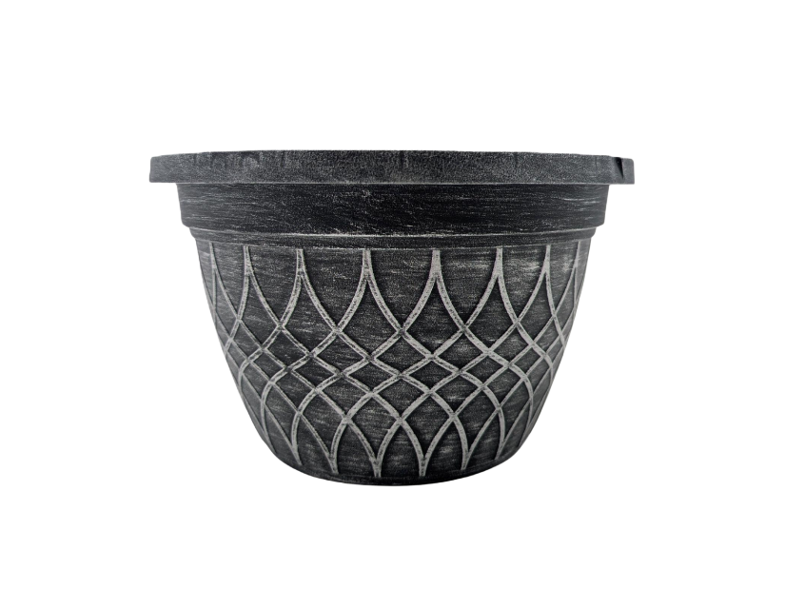
Byley planter
Suitable for indoor and outdoor use
Black/gold, black/silver
25cm

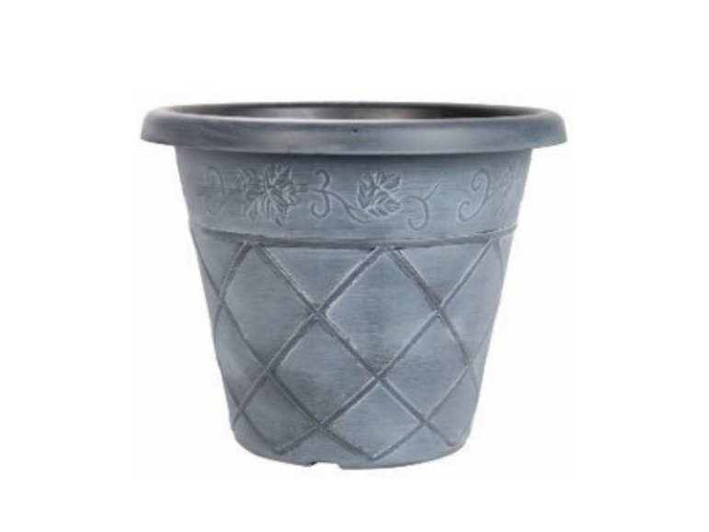
Antiqua planter
Round decorative plastic flowerpot
Black/bronze, black/white, black/green, terracotta/white
35cm 45cm

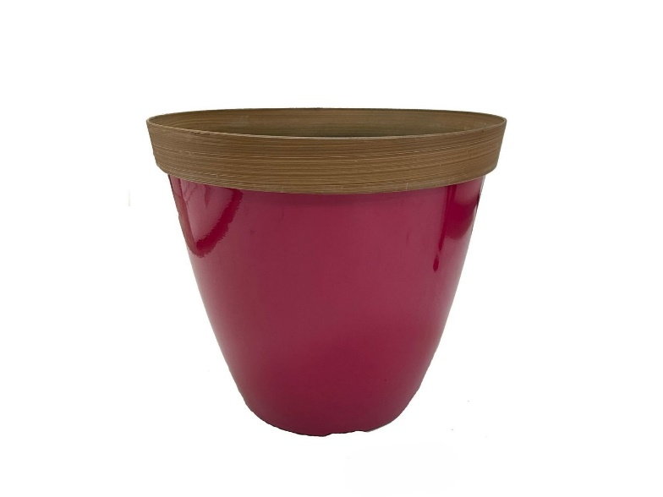
Bradwall planter
Eye catching plastic planters in vibrant colours
Blue/ lime green/ pink/ red/ white
23cm 30cm

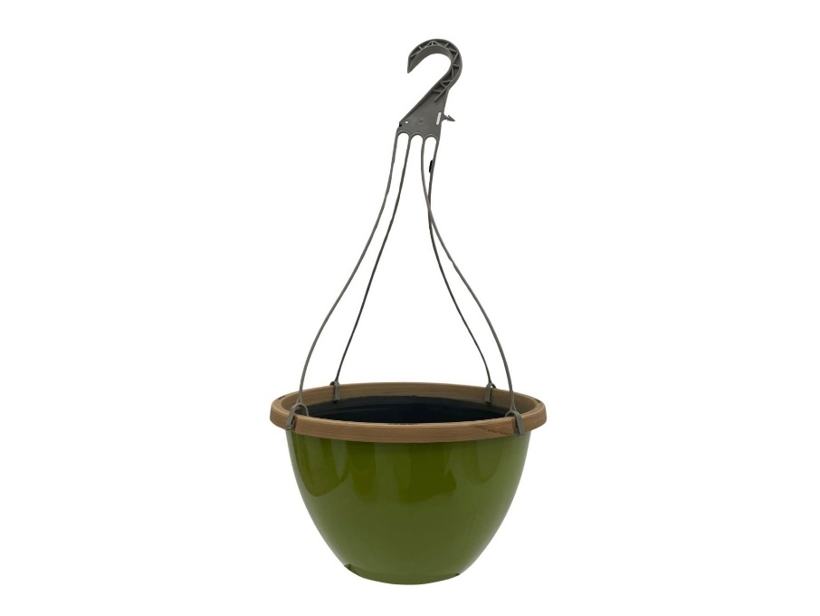
Bradwall hanging pot
Blue/ lime green/ pink/ red
30cm

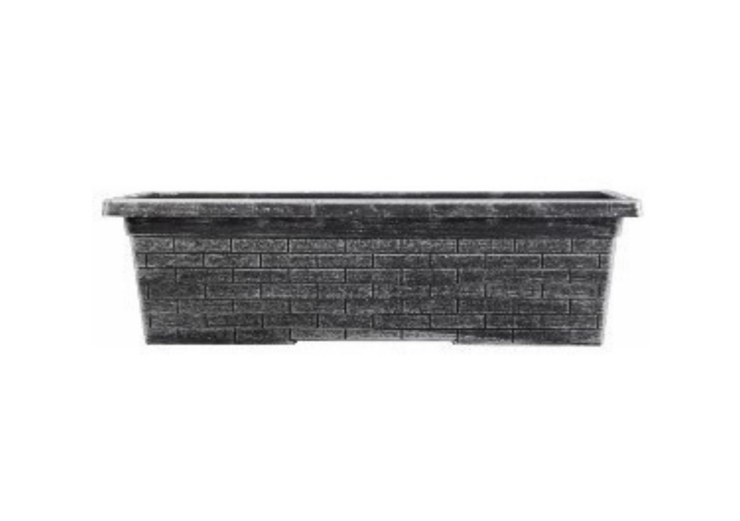
Old English trough
Heavy duty durable plastic
Black/bronze, black/silver
60x21.5x18cm

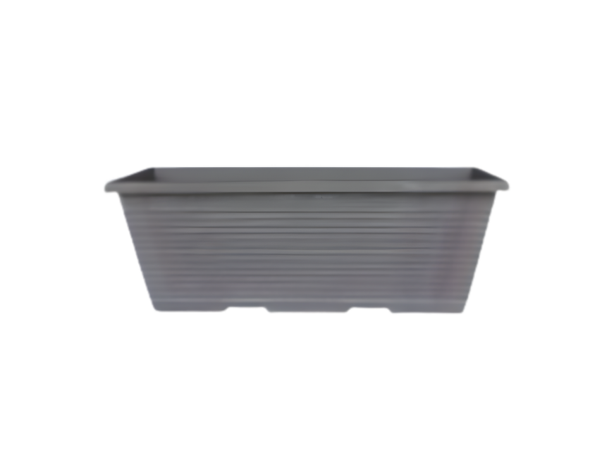
Helsby trough
Stylish minimalist design
Anthracite
38cm

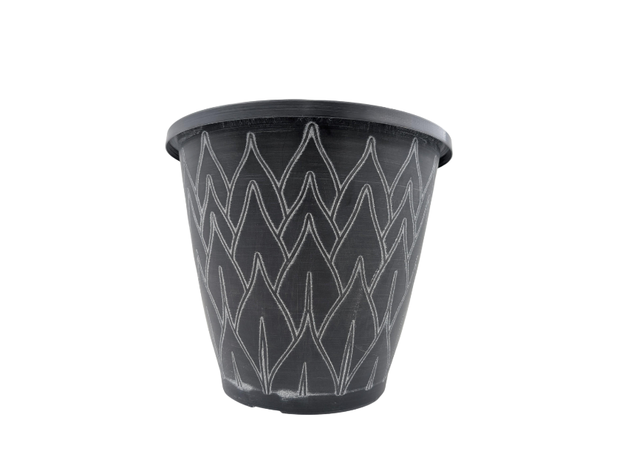
Tarvin planter
Heavy duty durable plastic
Black with whitewash
25cm - 30cm

All prices are plus VAT
Minimum order 10 units of any one planter
Subject to availability
Feb 2026

